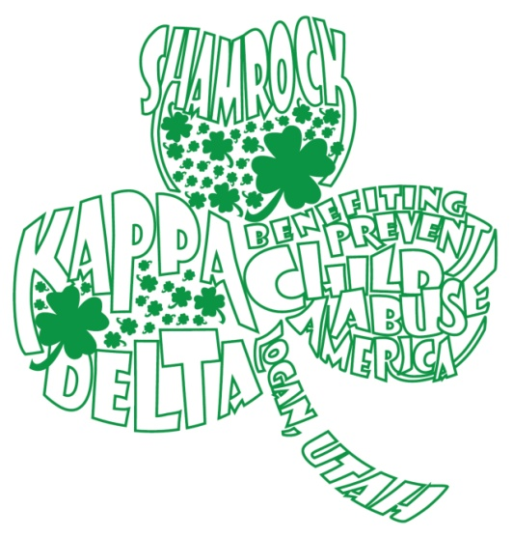
Kappa Delta
Shamrock Dodgeball Tournament
When: Friday, March 31
Where: USU Fieldhouse
Time: 7pm-9pm

Kappa Delta is excited to announce their Spring Shamrock Dodgeball Tournament. All proceeds raised at this event will go to The Family Place and Prevent Child Abuse America.
Each team must have 8 players. The cost is $10 per team.
Team Name: ___________________________________________________
Team Members (First and Last):

Team Captain: ___________________________
E-mail address: _________________________________________________________________________
Organization (if applicable): ___________________________________________________________
All registration is due Wednesday March 29, 2017, to the Kappa Delta house or venmo to Kalie Gilmour (@Kalie-Gilmour). Please make sure to include this registration form, waivers and money in an envelope.
Please call Kalie Gilmour (515) 778 – 9458 or Ashlee Flitton (801) 556-2880 with questions

